Question 1
- L1 = {w ∈ {0, 1}*: 0^{i}1^{j} where i ≤ j}
Answer: Assume, for the sake of contradiction, L1 is regular. Then let p be the pumping length for L1. Now if we take the string: w = 0^{p}1^{p} ∈ L1 , then the length of w is |w| = 2p ≥ p. So w can be split into xyz such that
- |xy| ≤ p ,
- |y| > 0 and
- xy^{i}z ∈ L1 for each i ≥ 0.
Assume, x = 0^{α} , y = 0^{β} and z = 0^{p-α-β}1^{p}
Since |xy| ≤ p, and the first p characters of w are all 0’s, we can conclude that y consists of only 0’s.
Then, for i = 2, xy²z = 0^{α}.0^{2β}.0^{p-α-β}1^{p} = 0^{p+β}1^{p} ∉ L1 since β can not be zero [|y| > 0].
We have excess 0’s in xy²z. Thus we get a contradiction! Hence, L1 is not a regular language.

b) L2 = {w ∈ {a, b, c}*: a^{i}b^{j}c^{k+2} where i = k and i, j, k ≥ 0}
Answer: Assume, for the sake of contradiction, L2 is regular. Then let p be the pumping length for L2. Now if we take the string: w = a^{p}bc^{p+2} ∈ L2 , then the length of w is |w| = 2p+3 ≥ p. So w can be split into xyz such that
- |xy| ≤ p ,
- |y| > 0 and
- xy^{i}z ∈ L2 for each i ≥ 0.
Assume, x = a^{α} , y = a^{β} and z = a^{p-α-β}bc^{p+2}
Since |xy| ≤ p, and the first p characters of w are all a’s, we can conclude that y consists of only a’s.
Then, for i = 2, xy²z = a^{α}.a^{2β}.a^{p-α-β}bc^{p+2} = a^{p+β}bc^{p+2} ∉ L2 since β can not be zero [|y| > 0].
We have excess a’s in xy²z. Thus we get a contradiction! Hence, L2 is not a regular language.

c) L3 = {w1#w2 such that |w1| = 2.|w2| , where w1, w2 ∈ {0, 1}* }
Answer: Assume, for the sake of contradiction, L3 is regular. Then let p be the pumping length for L3. Now if we take the string: w = 0^{2p}#1^{p} ∈ L3 , then the length of w is |w| = 3p+1 ≥ p. So w can be split into xyz such that
- |xy| ≤ p ,
- |y| > 0 and
- xy^{i}z ∈ L3 for each i ≥ 0.
Assume, x = 0^{α} , y = 0^{β} and z = 0^{2p-α-β}#1^{p}
Since |xy| ≤ p, and the first p characters of w are all 0’s, we can conclude that y consists of only 0’s.
Then, for i = 2, xy²z = 0^{α}.0^{2β}.0^{2p-α-β}#1^{p} = 0^{2p+β}#1^{p} ∉ L3 since β can not be zero [|y| > 0].
We have excess 0’s in xy²z. Thus we get a contradiction! Hence, L3 is not a regular language.

d) L4 = {w ∈ {a}*: $a^{2^{n}}$where n ≥ 0}
Answer: Assume, for the sake of contradiction, L4 is regular. Then let p be the pumping length for L4. Now if we take the string: w = $a^{2^{p}}$ ∈ L4 , then the length of w is |w| = 2^{p} ≥ p. So w can be split into xyz such that
- |xy| ≤ p ,
- |y| > 0 and
- xy^{i}z ∈ L4 for each i ≥ 0.
Assume, x = a^{α} , y = a^{β} and z = $a^{2^{p}-α-β}$
Then, for i = 2, xy²z = a^{α}.a^{2β}.$a^{2^{p}-α-β}$ = $a^{2^{p}+β}$ .
If xy²z ∈ L4, then $2^{p}+β$ should be a power of 2 (obviously $2^{p}+β$ > p). As β can not be zero, the immediate next power of $2^{p}$ is $2^{p+1}$.
So, $2^{p}+β$ > $2^{p+1}$
⇒ $2^{p}+β$ > ${2.2}^{p}$
⇒ $β$ > $2^{p}$

But from condition 1,
|xy| ≤ p
⇒ |y| ≤ p
⇒ $β$ ≤ p
Thus we get a contradiction! Hence, L4 is not a regular language.

e) L5 = {w10^{i} : w ∈ {0, 1}* , i ≥ 0 and |w| ≥ i}
Answer: Assume, for the sake of contradiction, L5 is regular. Then let p be the pumping length for L. Now if we take the string: w = 0^{p}10^{p} ∈ L , then the length of w is |w| = 2p + 1 ≥ p. So w can be split into xyz such that
- |xy| ≤ p ,
- |y| > 0 and
- xy^{i}z ∈ L for each i ≥ 0.

Assume, x = 0^{α} , y = 0^{β} and z = 0^{p-α-β}10^{p}
Since |xy| ≤ p, and the first p characters of w are all 0’s, we can conclude that y consists of only 0’s.

Then, for i = 0, xy⁰z = 0^{α}.0^{p-α-β}10^{p} = 0^{p-β}10^{p}
Now, p-β ≥ p => β ≤ 0
Therefore, 0^{p-β}10^{p} ∉ L since β > 0. Hence, L5 is not regular.

Question 2
- S → 1P
P → 0P | 1P | ε
Or, S → S0 | S1 | 1
- S → 0S0 | 1S1 | ε
- S → P001P
P → 0P | 1P | ε
- S → 0S0 | 1
- S → PS1 | ε
P → 0 | ε
Or, S → 0S1 | Z
Z → Z1 | ε
- S → 1S1 | 0P
P → 1P1 | 0
- S → 000S11 | X0X0X
X → 0X | 1X | ε
Or, S → 000S11 | A0A0X
A → 1A | ε
X → 0X | 1X | ε
- S → R1P
R → 000R | ε
P → 0P | ε
- 0^{i}10^{j} = 0^{i}10^{2+3i} = 0^{i}10²0^{3i} = 0^{i}1000^{3i}
S → 0S000 | 100
Or, 0^{i}10^{j} = 0^{i}10^{2+3i} = 0^{i}10^{3i}0² = 0^{i}10^{3i}00
S → P00
P → 0P000 | 1
- S → P0R | Q
R → 1111R | ε
P → 1P | ε
Q → 11Q1 | 1110

Question 3

- There are three possible parse trees to derive the given string. Drawing any two of the following will be correct.
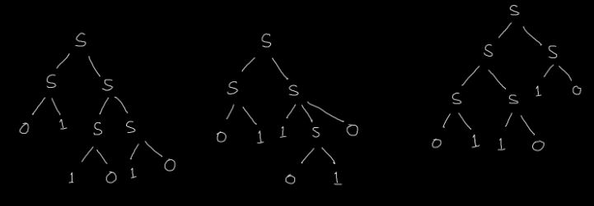
- Correct answers include 000111, 001110, 011100, 111000, 110001, 100011. Finding any two of these will be okay. Everything else is incorrect.

B.
- & b)
There are three different derivations of abababb.
^{P}  ^{(odd length palindrome)} | ^{E}  ^{(even length substring)}
ª  ^{aba}  ^{ababa} | ^{bababb}  ^{babb}  ^{bb}

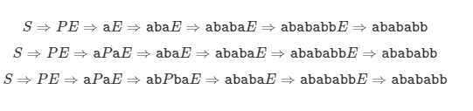
These are the three corresponding Parse Trees.
